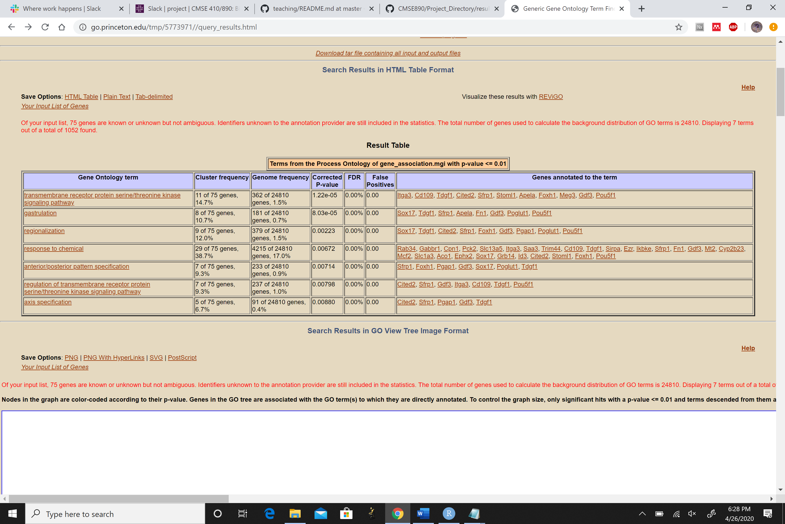

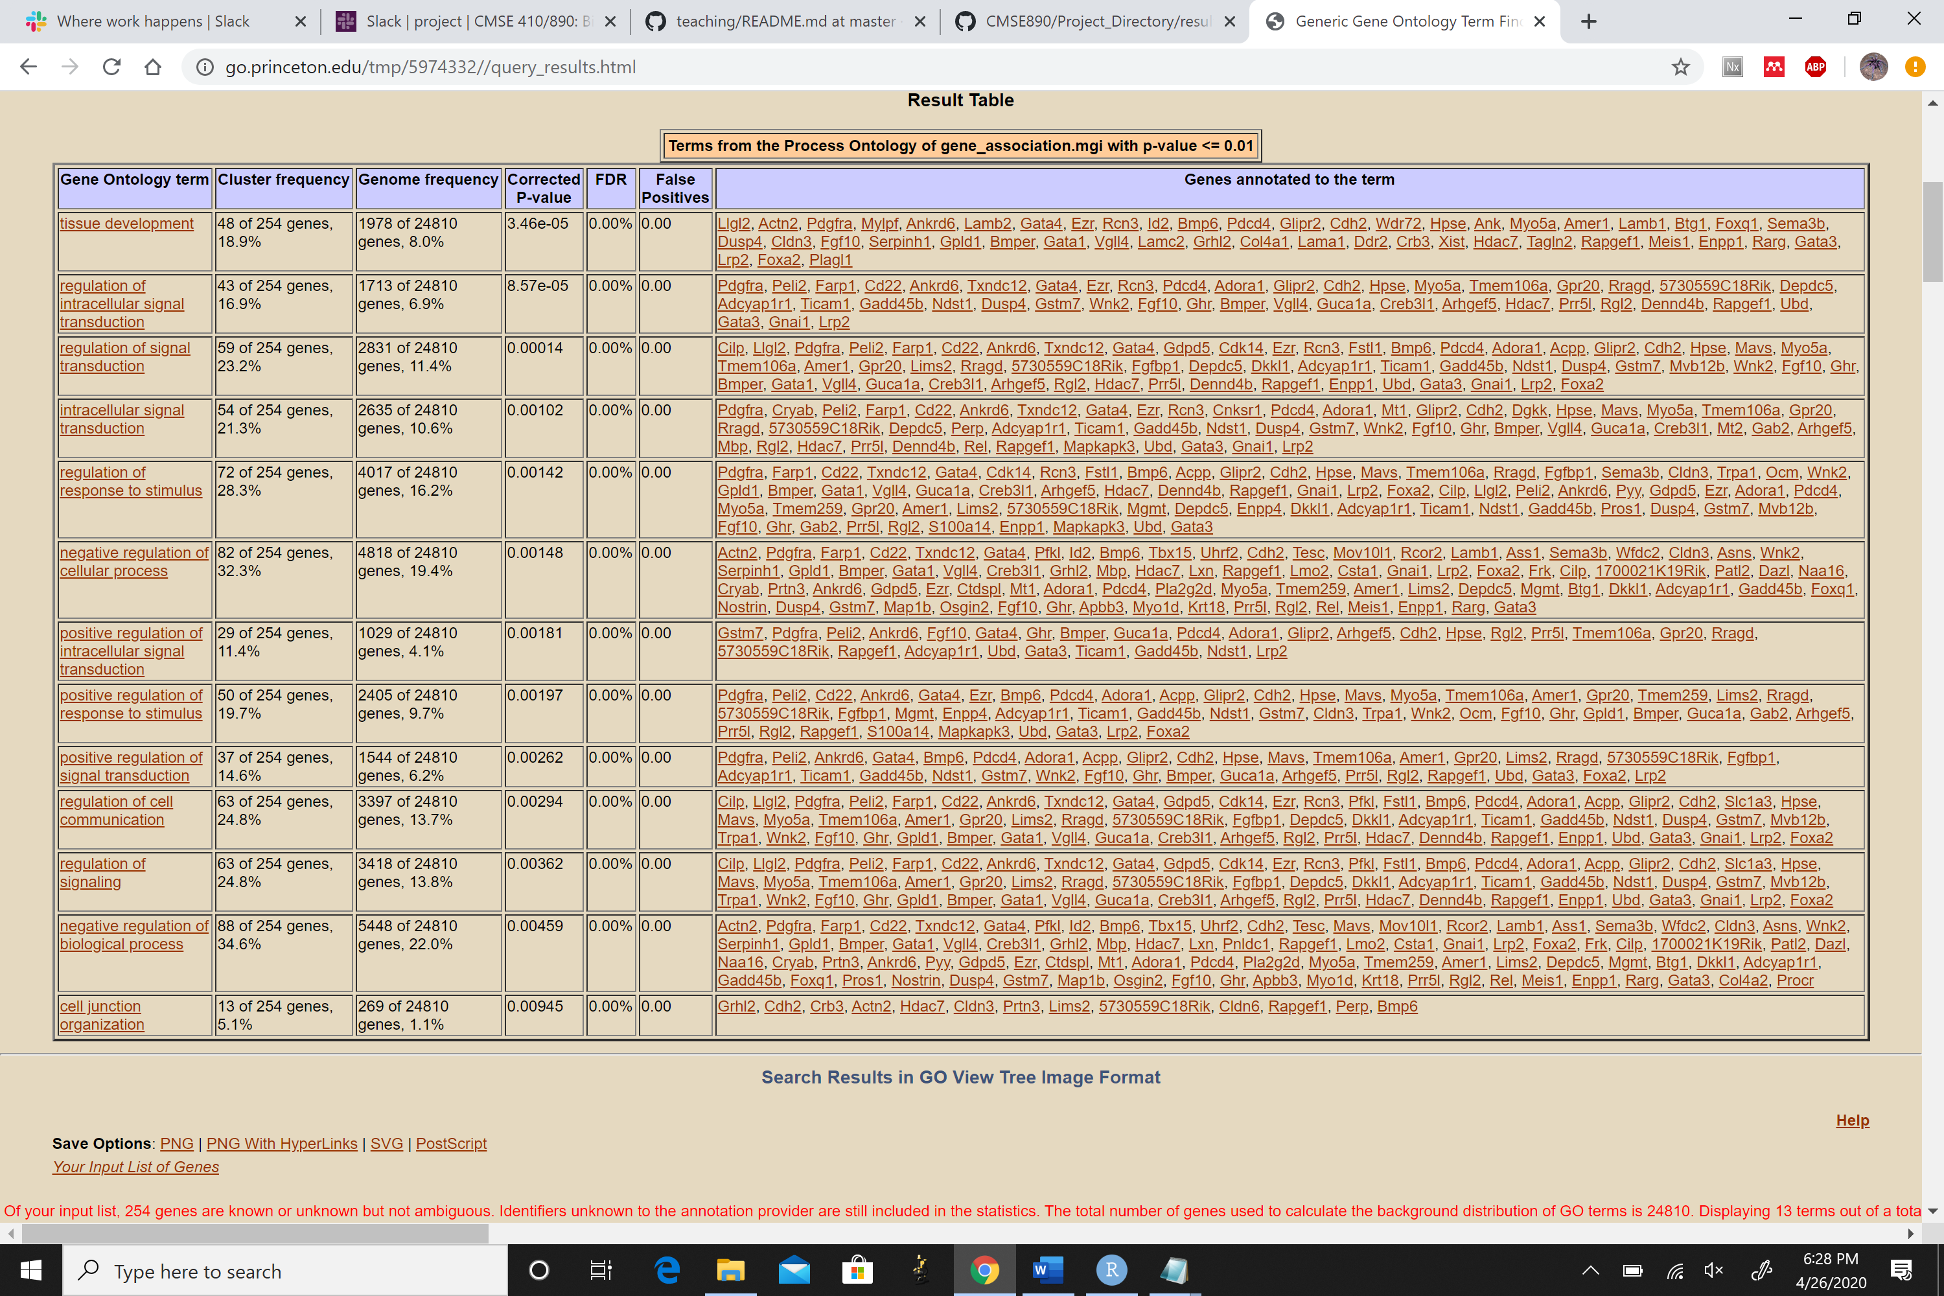**Figure 4: Generic GO results for differentially expressed genes in OCT4-/- embryos.**

**Figure 5: Generic GO results for differentially expressed genes in GATA6-/- embryos.**

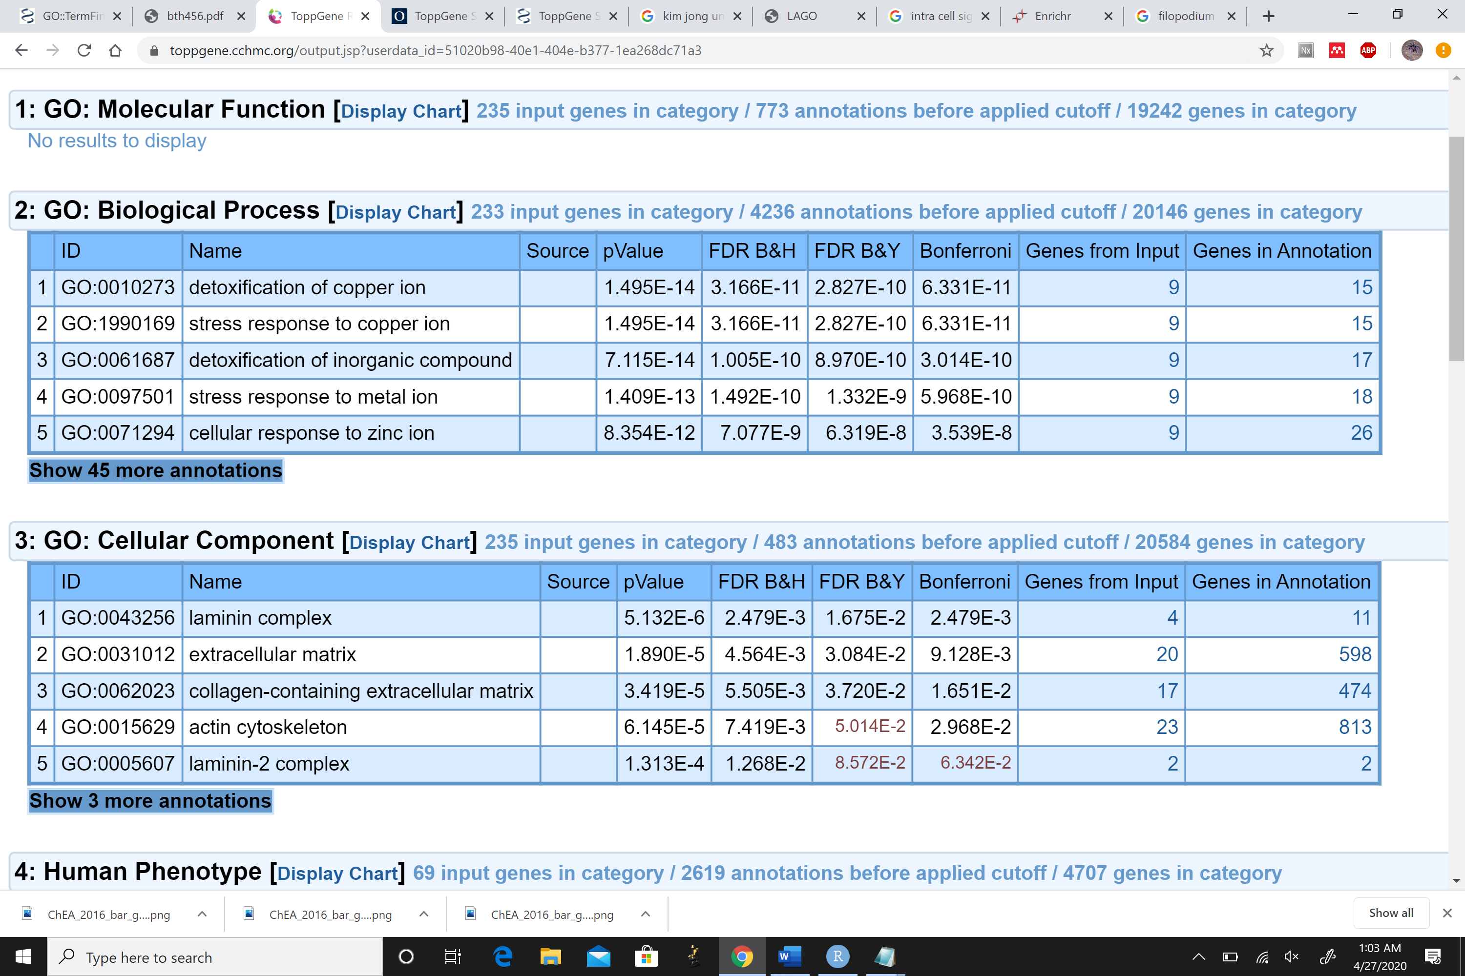

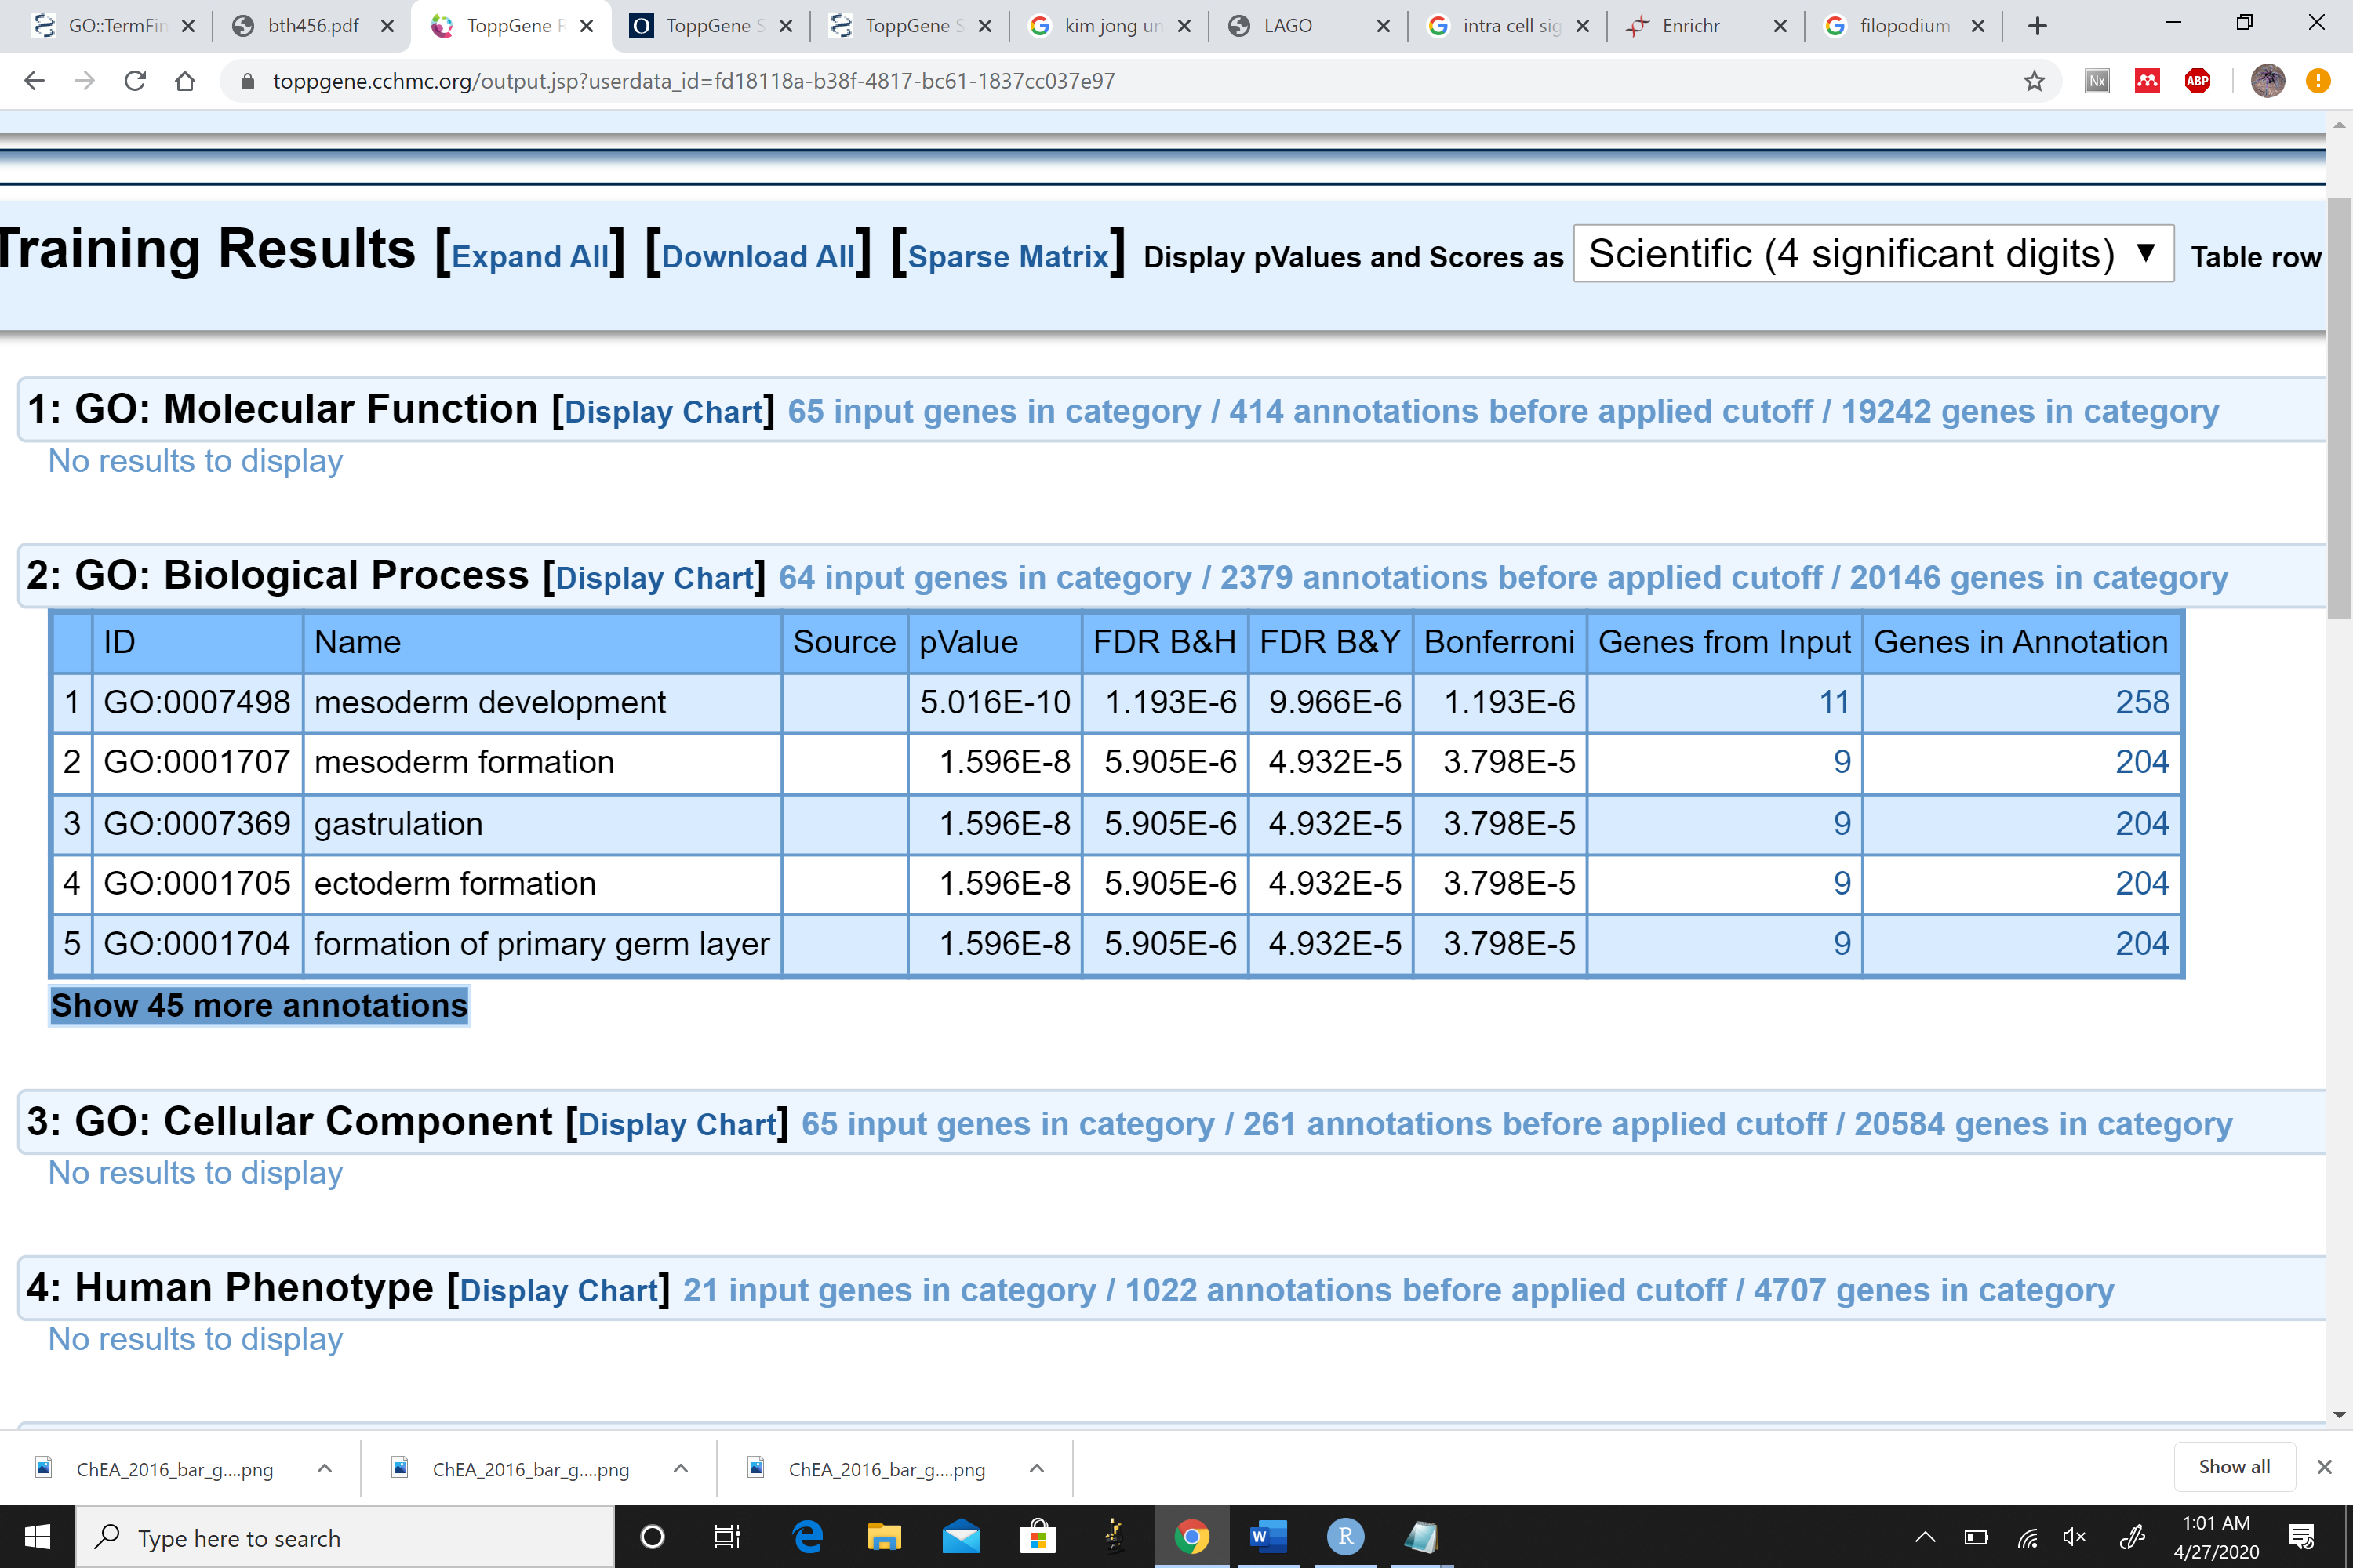**Figure 10: ToppFun results for differentially expressed genes in OCT4-/- embryos.**

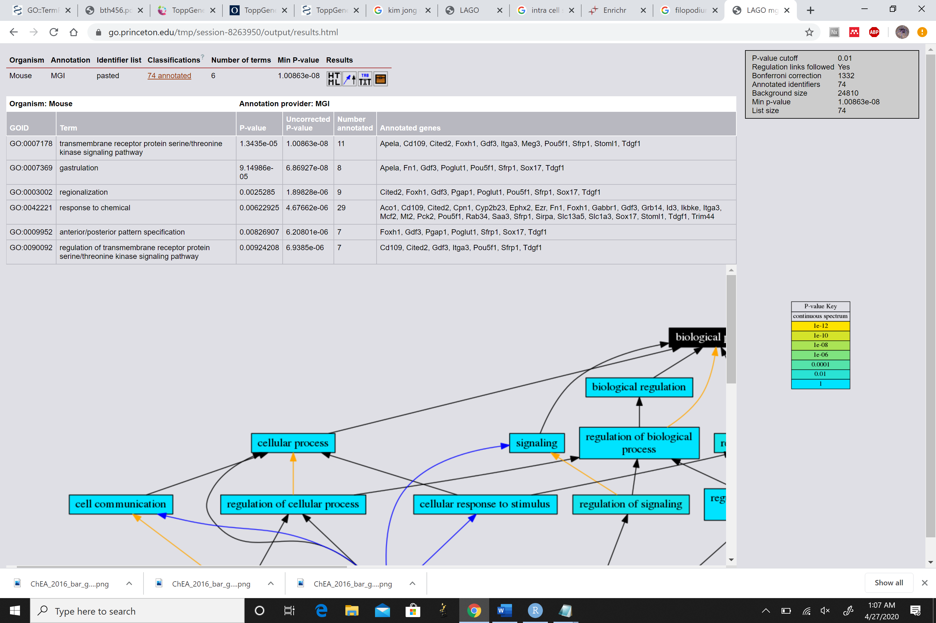**Figure 11: ToppFun results for differentially expressed genes in GATA6-/- embryos.**

**Figure 12: LAGO results for differentially expressed genes in OCT4-/- embryos.**

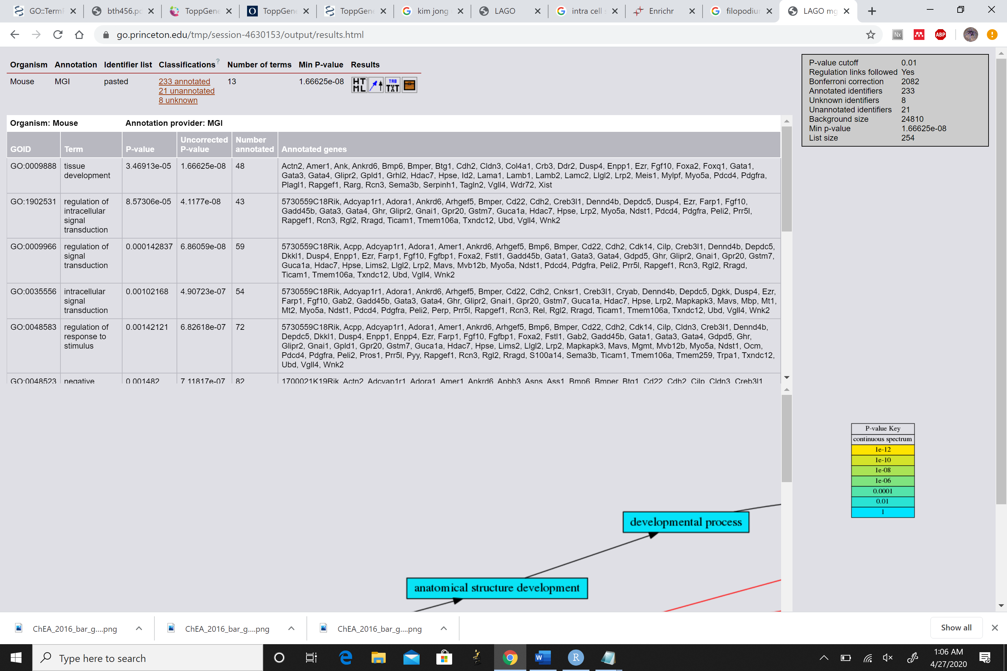**Figure 12: LAGO results for differentially expressed genes in OCT4-/- embryos.**

Supplemental Figures

**Supplemental Figure 1: Mapped biological processes of Generic GO results for differentially expressed genes in OCT4-/- embryos.**

**Supplemental Figure 2: Mapped biological processes of Generic GO results for differentially expressed genes in GATA6-/- embryos.**

